**PRACTICE 5**

**5. (*)** The agents 001,002,003,004,005,006,007 & 008 are working in a mission in order to save the world (one more time). Every agent must have the chance to contact directly or indirectly with the rest of agents. Set a communication between two agents has certain risk. In the following table you have the risk factors associated to the direct communications between two agents (the higher the number, the higher the risk). The rest of communications have been intercepted. What is the minimum total risk for a communication system?

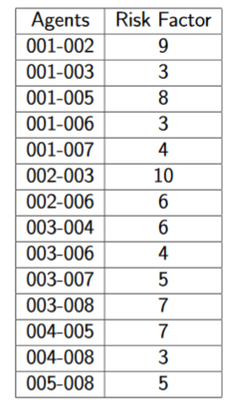

SOLUTION (weight = 30):

